Experiment-3

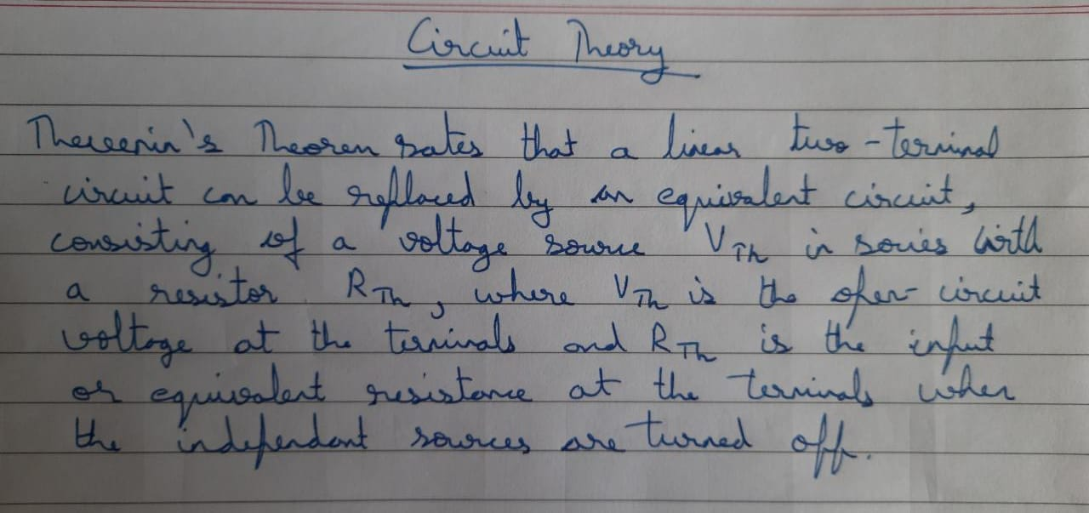

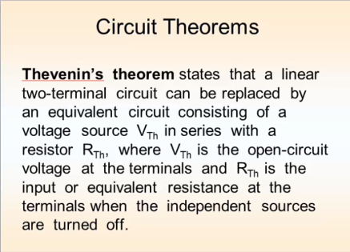

The Circuit:

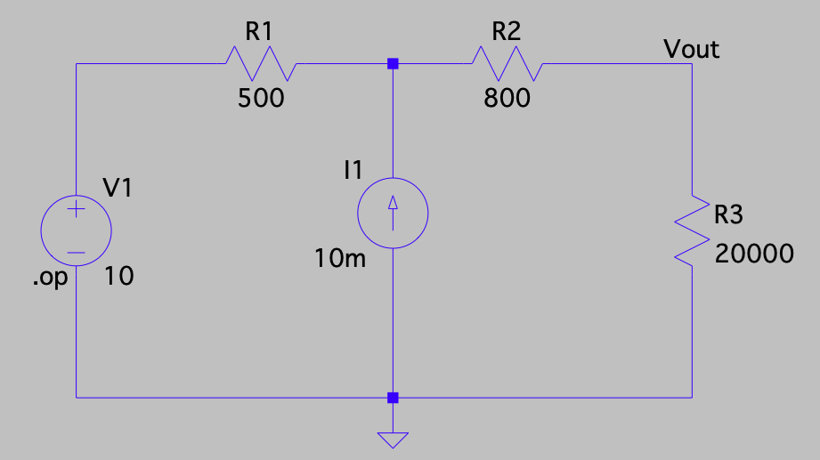

Operating Point: -

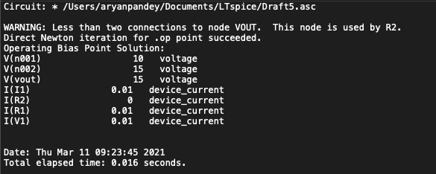

Open Circuit: -

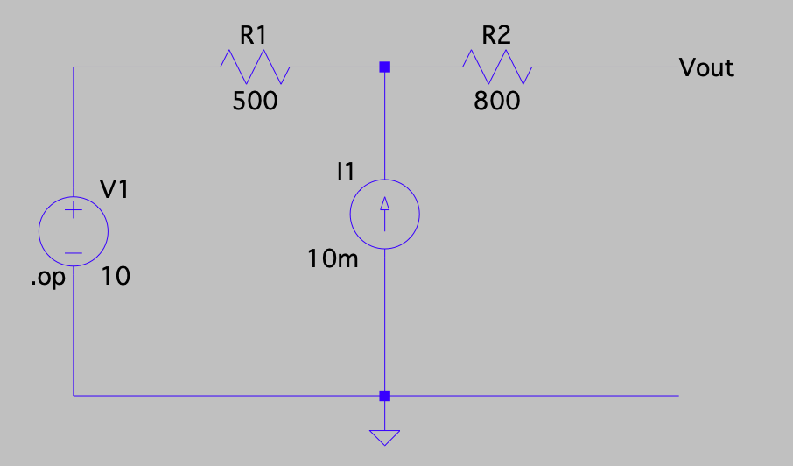

Operating Point: -

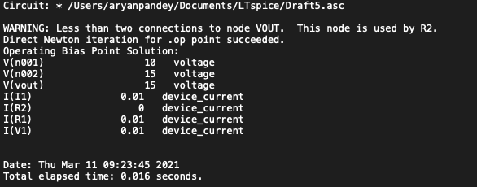

__________________________________________________________________________________

__________________________________________________________________________________

The Simplified Circuit: -

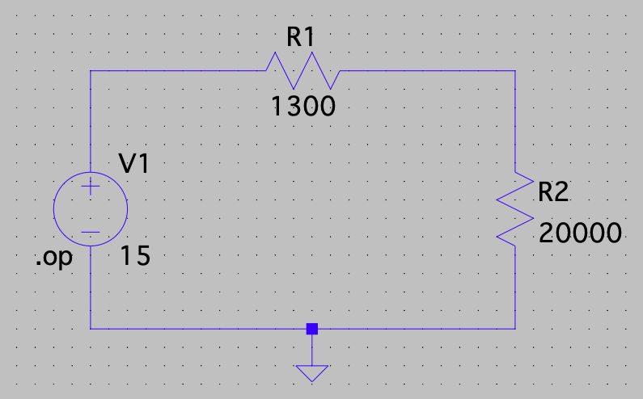

Operating Point: -

